Java Programming Practice

Exercise 1. Write a program that prints a greeting of your choice.

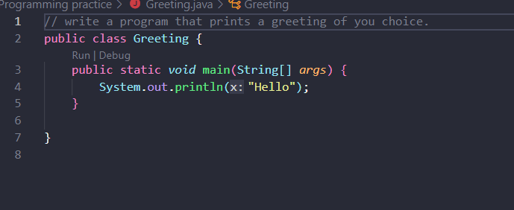

In the above program, at first, I created a file name called Greeting.java after that in coding I create a class name which is same as file name that is “public class Greeting” after that I used main method, main method in every java application contains main method then the java compiler starts executing the code from the main method. Then I used print statement that helps to print text “Hello”.

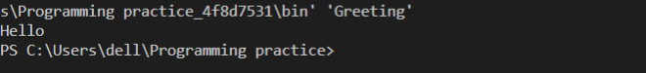

Exercise 2. Write a program that prints the sum of the first ten positive integers.

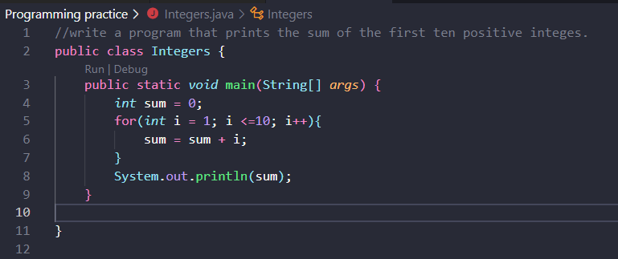

In above program, at first, I create a file name of this above program called Integers.java after that I named a class name that is Integer and then in main method, I initialized a variable for I used a datatype integer (int) and variable name sum and assignment operator” =” then I used a for loop to run a block of code for a certain number of times. Here, the value of sum is zero initially. Then, the for loop is iterated from i = 1 to 10. In each iteration, i is added to sum and its value increased by 1. When i becomes 11, the test condition is false and sum is equal to 1+2+………. +10.

Output: sum = 55.

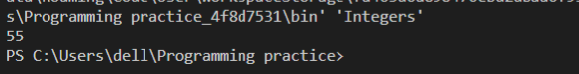

Exercise 3. Write a program that prints the product of the first ten positive numbers.

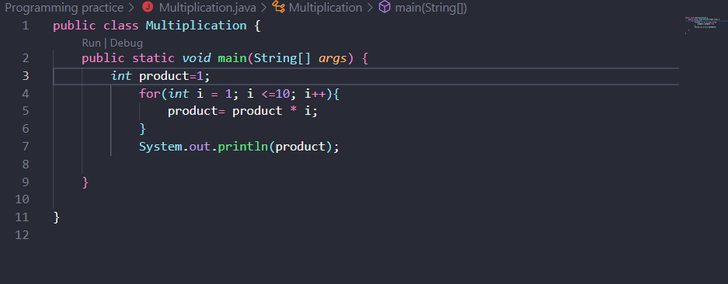

In above program, at first, I create a file name of this above program called Multiplication.java after that I named a class name that is Multiplication and then in main method, I initialized a variable for I used a datatype integer (int) and variable name product and assignment operator” =” then I used a for loop to run a block of code for a certain number of times. Here, the value of sum is 1 initially. Then, the for loop is iterated from i = 1 to 10. In each iteration, i is multiplied to product and its value increased by 1. When i becomes 11, the test condition is false and product is equal to 1\*2+\*………. \*10.

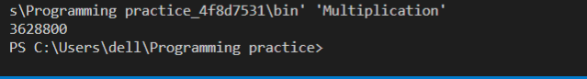

Exercise 4. Write a program that prints the balance of an account after the first, second, third year.

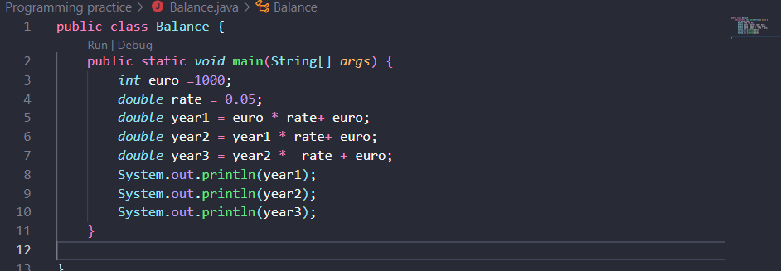

In the above program, I create a file name called Balance.java and then after that I start a program. In program at first, I keep the class name called Balance which is same as file name. In main method I declared variables called euro, rate, year1, year2 and year3 where euro is type of int and rate, year1, year2 and year3 are type of double. After that I used a print statement to print the first, second, third year result.

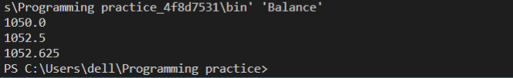

Exercise 5. Write a program that displays your name inside the box of the screen.

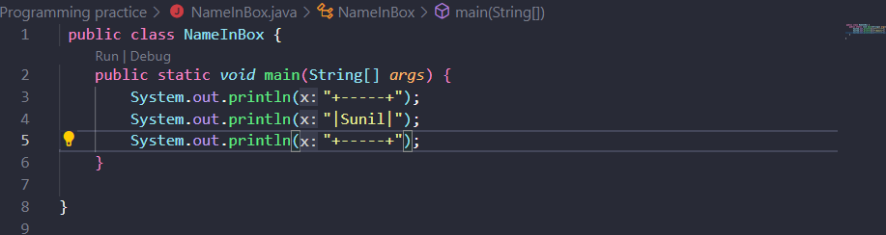

First, I create a filed name which is called NameInBox.java. Starting my code, I defined a class name which is same as file name. Then I used a print statement which is System.out.println(); to print the console or output to the screen.

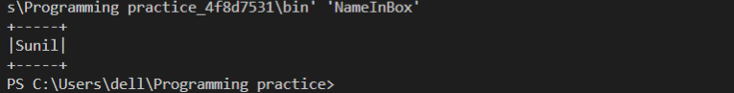

Exercise 6.

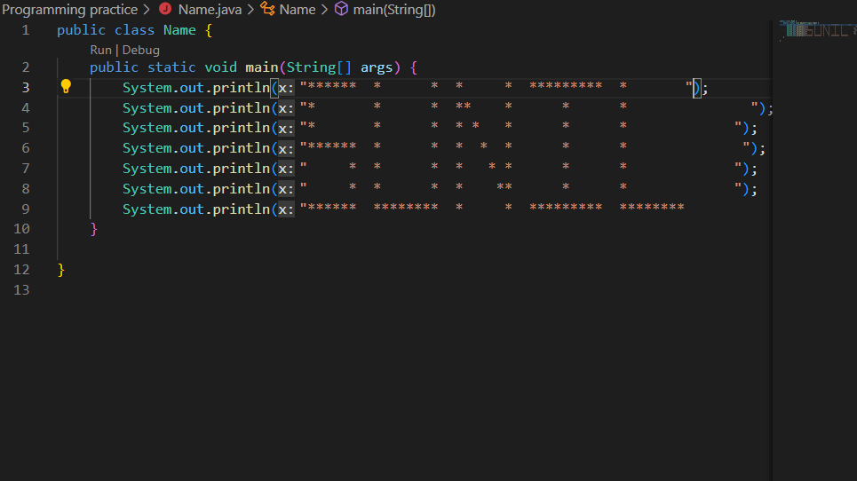

In this above program, I generated file name called Name.java then starting my code, I assigned a class name called Name class which is similar as file name and then I declared a print statement to print ‘\*’ symbol to create a name.

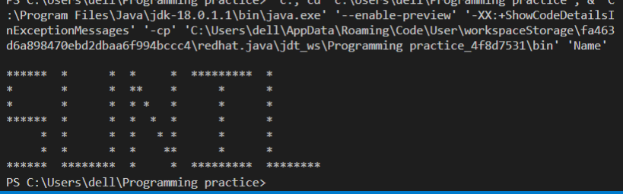

Exercise 7. Write a program that prints a face.

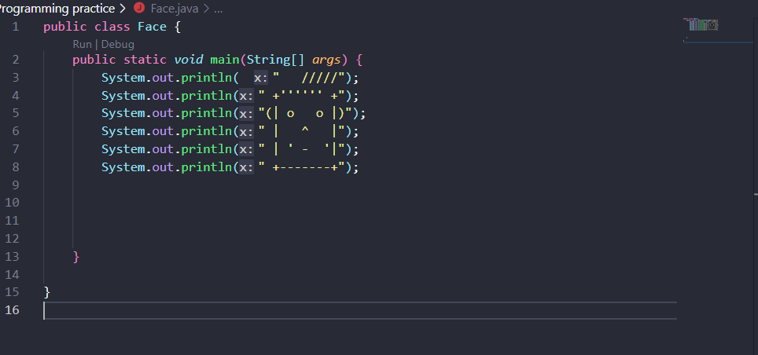

In the above program first, I created a file name which is called Face.java. Starting my code, I defined a class name which is same as file name. Next, I displayed in the console what I want from them.

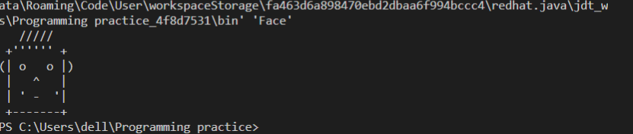  
Exercise 8. Write a program that prints a house looks.

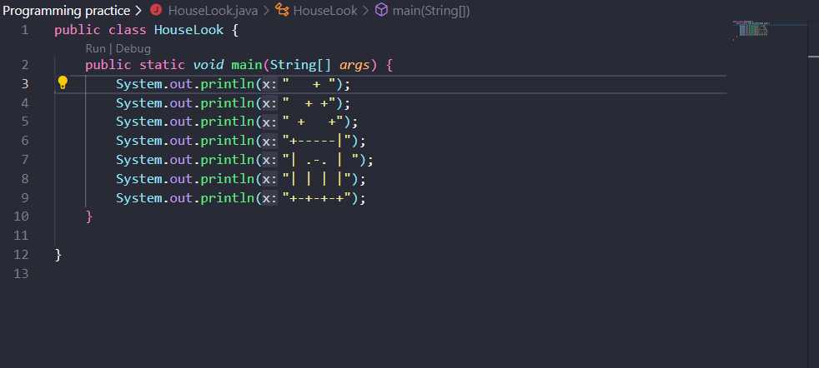

In the above program first, I created a file name which is know as HouseLook.java. Starting my code, I declared a class name which is same as file name after that I used main method () syntax which is the entry point of any java program. Next, I declared a print statement to print the console. In the code I used a character in print statement like /, -, +, |.

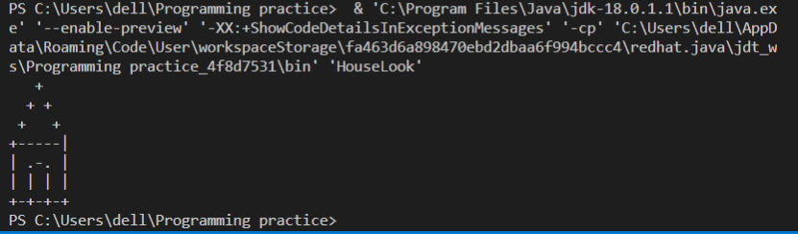

Exercise 9.

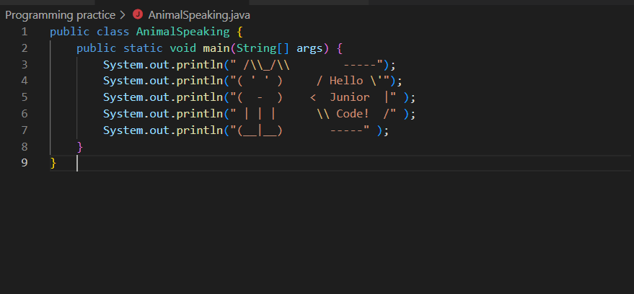

In the above program at first, I created a file name called AnimalSpeaking.java and then starting my code I defined a class name called AnimalSpeaking class after this defined a print statement to print what want with main method.

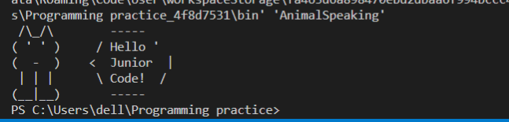

Exercise 10.

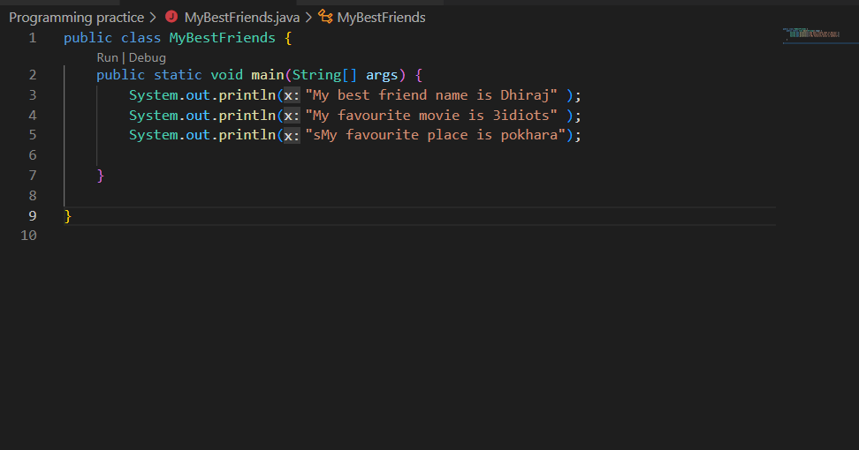

In this above program, first I generated a file name called MyBestFriend.java and I defined a class name which is same as file name called public class MyBestFriend{}. After that using print statement to print console on different line.

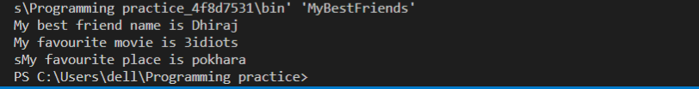

Exercise11.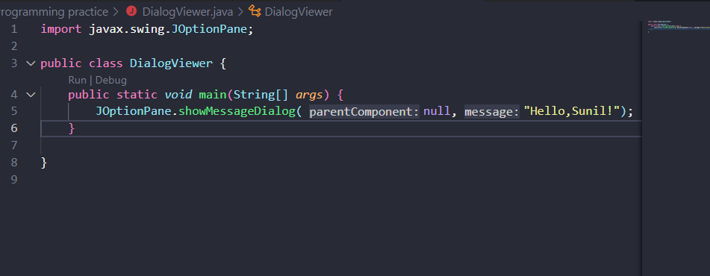

In this above program first, I created a file name called DialogViewer.java then starting my program, first imported the library for taking input from users; import javax. swing. JOptionPlanr;

After this I defined a class name then I main method I defined JOptionPane.showMessageDialog(); method to create a message dialog with given tittle and message

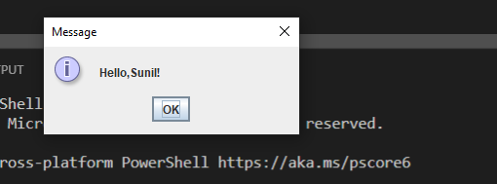

Exercise12.

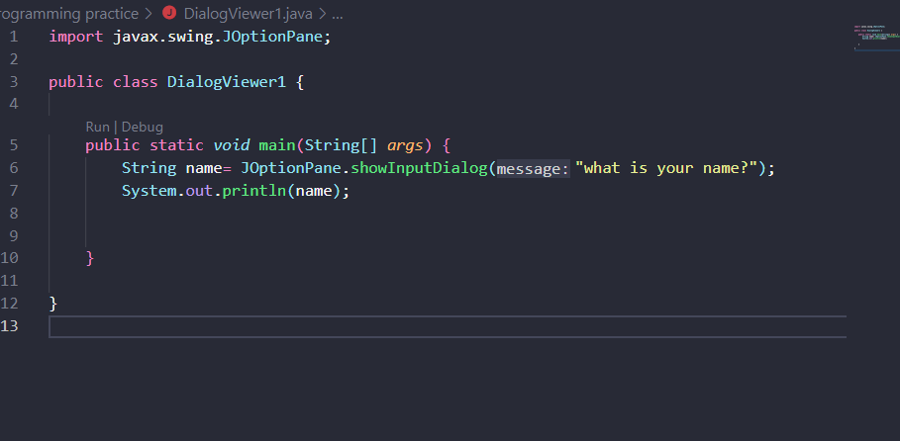

In this above program first, I created a file name called DialogViewer1.java then starting my program, first imported the library for taking input from users; import javax. swing. JOptionPlanr;

After this I defined a class name then I main method I defined JOptionPane.showinputDialog(); method to show a question message dialog requesting input from the user parented to parent Component.

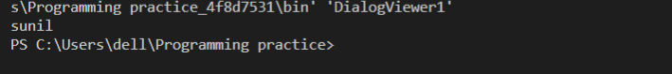

Exercise 13.

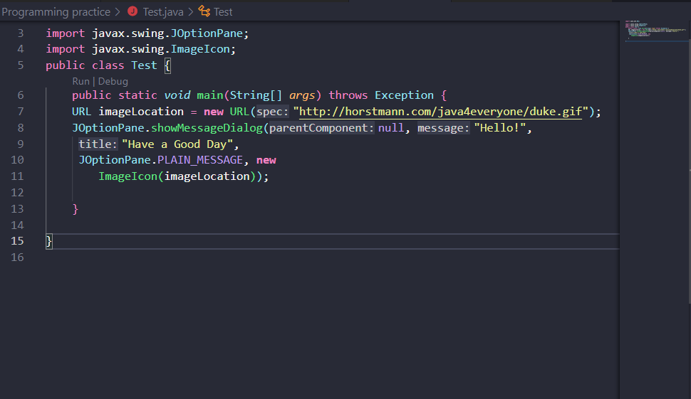

In this above program first, I created a file name called Test.java and then starting my code, I imported the library to take input from the user; import.java.net.url; and importjavax. swing. JOptionPlane; and import javax. ImageIcon; then I defined a class name same as file name and in main method I declared a constructor and then I defined JOptionPane.showmessageDialog to create a message dialog with given tittle and message type.

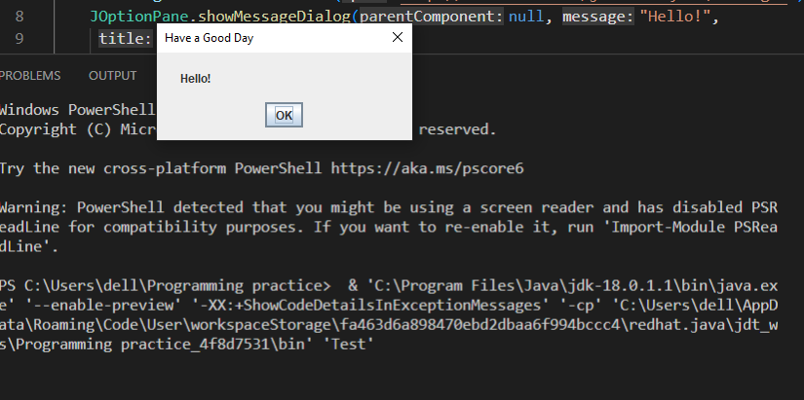

Exercise 14. Write a program that prints a two-column list with the greeting phrases shown in the following table. In the first column, print the phrase in English: in the second column, print the phrase in a language of your choice.

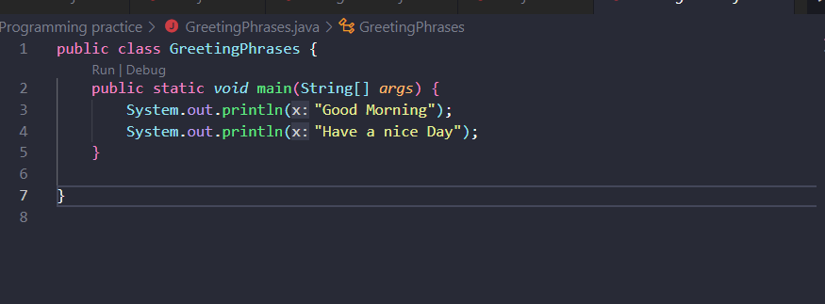

In the above program, at first, I crate a file name called GreetingPhrases.java after that in coding I create a class name which is same as file name that is “public class GreetingPhrases {}” after that I used main method, main method in every java application contains main method then the java compiler starts executing the code from the main method. Then I used print statement that helps to print text “Good Morning” and “Have a nice Day” in separate line.



